**AR AGING REPORT DOC**

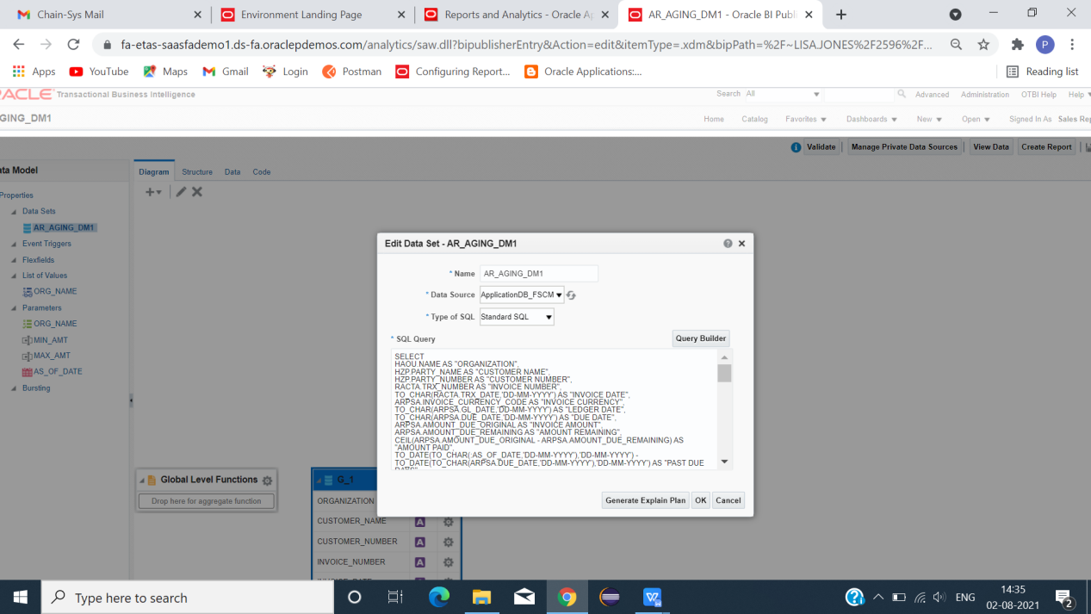

CLICK -> NEW -> DATAMODEL.

TYPE AP AGING QUERY.

**DATA MODEL QUERY**

SELECT

HAOU.NAME AS "ORGANIZATION",

HZP.PARTY_NAME AS "CUSTOMER NAME",

HZP.PARTY_NUMBER AS "CUSTOMER NUMBER",

RACTA.TRX_NUMBER AS "INVOICE NUMBER",

TO_CHAR(RACTA.TRX_DATE,'DD-MM-YYYY') AS "INVOICE DATE",

ARPSA.INVOICE_CURRENCY_CODE AS "INVOICE CURRENCY",

TO_CHAR(ARPSA.GL_DATE,'DD-MM-YYYY') AS "LEDGER DATE",

TO_CHAR(ARPSA.DUE_DATE,'DD-MM-YYYY') AS "DUE DATE",

ARPSA.AMOUNT_DUE_ORIGINAL AS "INVOICE AMOUNT",

ARPSA.AMOUNT_DUE_REMAINING AS "AMOUNT REMAINING",

CEIL(ARPSA.AMOUNT_DUE_ORIGINAL - ARPSA.AMOUNT_DUE_REMAINING) AS "AMOUNT PAID",

TO_DATE(TO_CHAR(:AS_OF_DATE,'DD-MM-YYYY'),'DD-MM-YYYY') - TO_DATE(TO_CHAR(ARPSA.DUE_DATE,'DD-MM-YYYY'),'DD-MM-YYYY') AS "PAST DUE DAYS",

CASE WHEN

TO_DATE(TO_CHAR(:AS_OF_DATE,'DD-MM-YYYY'),'DD-MM-YYYY') - TO_DATE(TO_CHAR(ARPSA.DUE_DATE,'DD-MM-YYYY'),'DD-MM-YYYY') >= -999 AND TO_DATE(TO_CHAR(:AS_OF_DATE,'DD-MM-YYYY'),'DD-MM-YYYY') - TO_DATE(TO_CHAR(ARPSA.DUE_DATE,'DD-MM-YYYY'),'DD-MM-YYYY') < 0

THEN ARPSA.AMOUNT_DUE_REMAINING ELSE 0

END "CURRENT BUCKET",

CASE WHEN

TO_DATE(TO_CHAR(:AS_OF_DATE,'DD-MM-YYYY'),'DD-MM-YYYY') - TO_DATE(TO_CHAR(ARPSA.DUE_DATE,'DD-MM-YYYY'),'DD-MM-YYYY') >= 0 AND TO_DATE(TO_CHAR(:AS_OF_DATE,'DD-MM-YYYY'),'DD-MM-YYYY') - TO_DATE(TO_CHAR(ARPSA.DUE_DATE,'DD-MM-YYYY'),'DD-MM-YYYY') < 30

THEN ARPSA.AMOUNT_DUE_REMAINING ELSE 0

END "0 T0 30 DAYS",

CASE WHEN

TO_DATE(TO_CHAR(:AS_OF_DATE,'DD-MM-YYYY'),'DD-MM-YYYY') - TO_DATE(TO_CHAR(ARPSA.DUE_DATE,'DD-MM-YYYY'),'DD-MM-YYYY') >= 31 AND TO_DATE(TO_CHAR(:AS_OF_DATE,'DD-MM-YYYY'),'DD-MM-YYYY') - TO_DATE(TO_CHAR(ARPSA.DUE_DATE,'DD-MM-YYYY'),'DD-MM-YYYY') < 60

THEN ARPSA.AMOUNT_DUE_REMAINING ELSE 0

END "31 TO 60 DAYS",

CASE WHEN

TO_DATE(TO_CHAR(:AS_OF_DATE,'DD-MM-YYYY'),'DD-MM-YYYY') - TO_DATE(TO_CHAR(ARPSA.DUE_DATE,'DD-MM-YYYY'),'DD-MM-YYYY') >= 61 AND TO_DATE(TO_CHAR(:AS_OF_DATE,'DD-MM-YYYY'),'DD-MM-YYYY') - TO_DATE(TO_CHAR(ARPSA.DUE_DATE,'DD-MM-YYYY'),'DD-MM-YYYY') < 90

THEN ARPSA.AMOUNT_DUE_REMAINING ELSE 0

END "61 TO 90 DAYS",

CASE WHEN

TO_DATE(TO_CHAR(:AS_OF_DATE,'DD-MM-YYYY'),'DD-MM-YYYY') - TO_DATE(TO_CHAR(ARPSA.DUE_DATE,'DD-MM-YYYY'),'DD-MM-YYYY') >= 91 AND TO_DATE(TO_CHAR(:AS_OF_DATE,'DD-MM-YYYY'),'DD-MM-YYYY') - TO_DATE(TO_CHAR(ARPSA.DUE_DATE,'DD-MM-YYYY'),'DD-MM-YYYY') < 120

THEN ARPSA.AMOUNT_DUE_REMAINING ELSE 0

END "91 TO 120 DAYS",

CASE WHEN

TO_DATE(TO_CHAR(:AS_OF_DATE,'DD-MM-YYYY'),'DD-MM-YYYY') - TO_DATE(TO_CHAR(ARPSA.DUE_DATE,'DD-MM-YYYY'),'DD-MM-YYYY') >= 121 AND TO_DATE(TO_CHAR(:AS_OF_DATE,'DD-MM-YYYY'),'DD-MM-YYYY') - TO_DATE(TO_CHAR(ARPSA.DUE_DATE,'DD-MM-YYYY'),'DD-MM-YYYY') < 999999

THEN ARPSA.AMOUNT_DUE_REMAINING ELSE 0

END "MORE THAN 120 DAYS"

FROM

HR_ALL_ORGANIZATION_UNITS HAOU,

HZ_PARTIES HZP,

RA_CUSTOMER_TRX_ALL RACTA,

AR_PAYMENT_SCHEDULES_ALL ARPSA

WHERE 1=1

AND RACTA.ORG_ID = HAOU.ORGANIZATION_ID(+)

AND RACTA.CUSTOMER_TRX_ID = ARPSA.CUSTOMER_TRX_ID(+)

AND RACTA.SOLD_TO_PARTY_ID = HZP.PARTY_ID(+)

AND HAOU.NAME = NVL( :ORG_NAME, HAOU.NAME)

AND HAOU.NAME IN ('France Business Unit','US1 Business Unit','China Business Unit','Progress US Business Unit')

AND ARPSA.GL_DATE <= :AS_OF_DATE

AND ARPSA.AMOUNT_DUE_ORIGINAL >= NVL( :MIN_AMT,0)

AND ARPSA.AMOUNT_DUE_ORIGINAL <= NVL( :MAX_AMT,999999)

AND ARPSA.AMOUNT_DUE_REMAINING > 0

AND ARPSA.AMOUNT_DUE_ORIGINAL - ARPSA.AMOUNT_DUE_REMAINING != 0

**PARAMETERS**

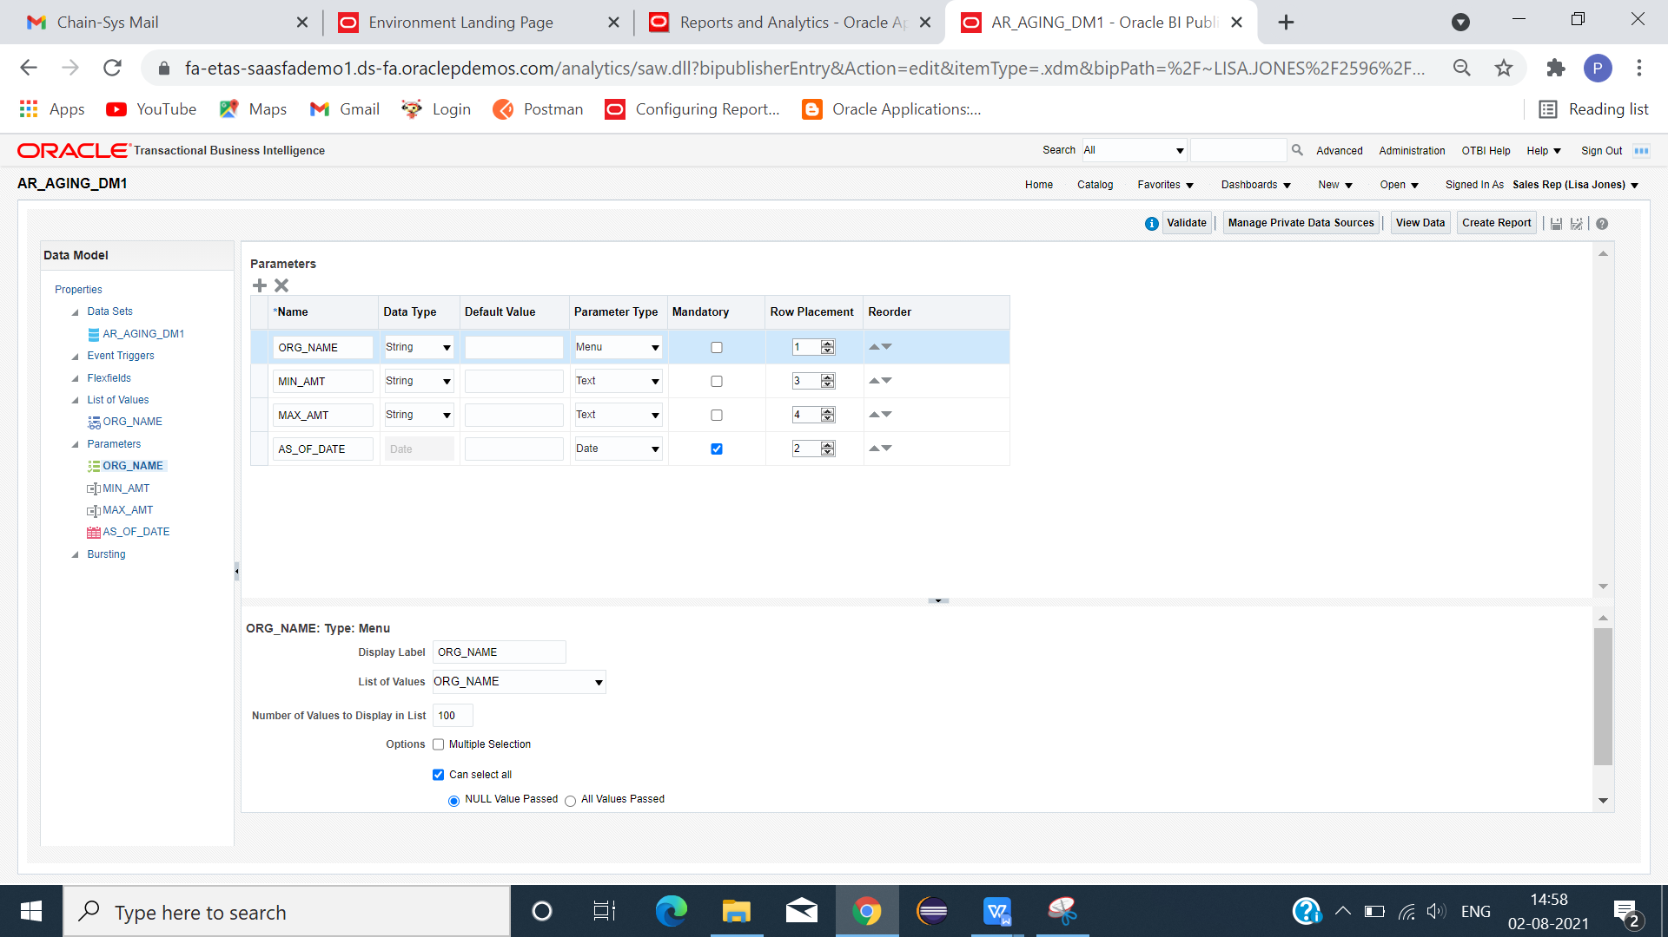

**LIST OF VALUES QUERY**

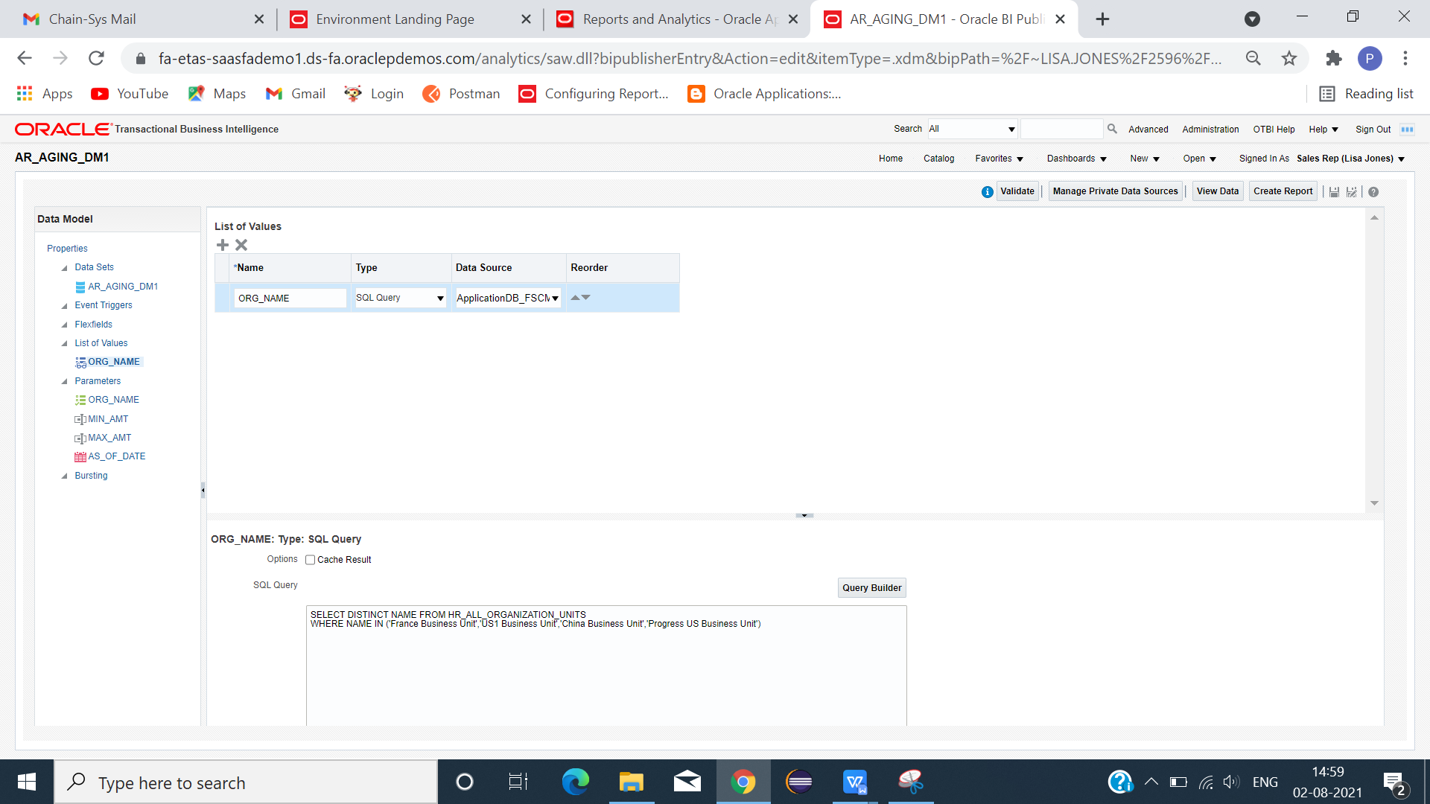

**ORG_NAME:**

SELECT DISTINCT NAME FROM HR_ALL_ORGANIZATION_UNITS

WHERE NAME IN ('France Business Unit','US1 Business Unit','China Business Unit','Progress US Business Unit')

CLICK DATA -> SAVE -> VIEW -> VIEW SAMPLE DATA -> SAVE -> EXPORT(XML FILE).

**EXCEL TEMPLATE**

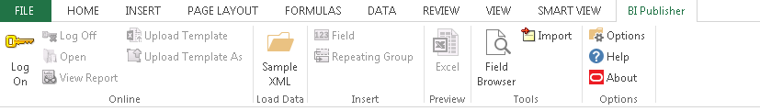

CLICK SAMPLE XML(LOAD DATA) - > LOAD XML FILE -> FIELD(META DATA CREATED) .

INSERT COLUMNS USING FIELDS(PARAMETER AND REQUIRED COLUMNS).

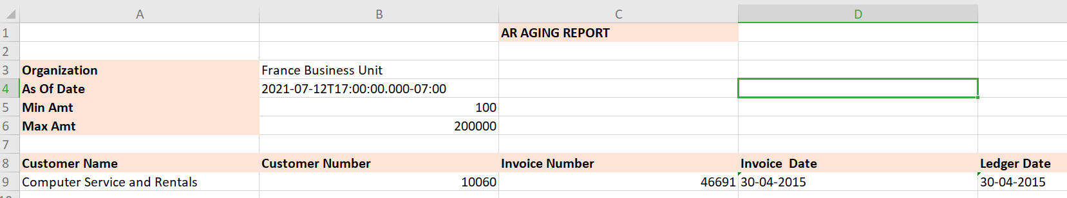

SAVE TEMPLATE AS (EXCEL 2003 WORKBOOK) FORMAT.

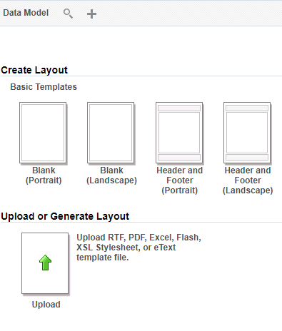

LOAD DATA MODE -> CLICK UPLOAD OR GENERATE LAYOUT.

GIVE LAYOUT NAME -> LOAD TEMPLATE -> CHOOSE TEMPLATE FORMAT -> LOCALE -> OK

SAVE -> REPORT -> RUN

REPORT SUCCESSFULLY GENERATED IN EXCEL FORMAT.

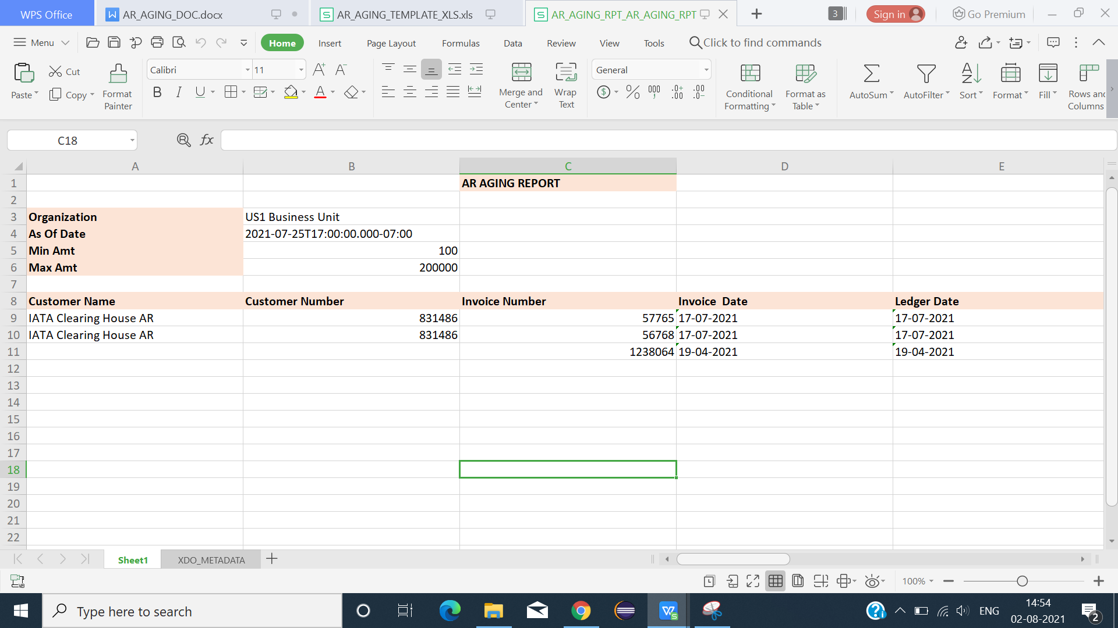

FINAL OUTPUT RESULT IN EXCEL FORMAT.

===================================================================================